Harvey Segur
July 30, 1857 – April 12, 1943

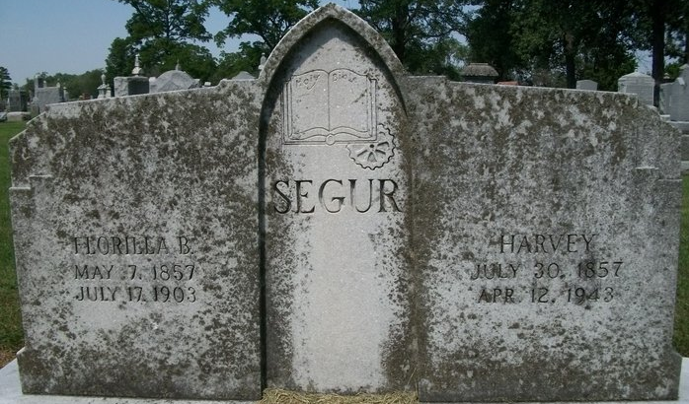
Photo by Deb Curry

Harvey Segur
in the Illinois, U.S., Deaths and Stillbirths Index, 1916-1947
Name Harvey Segur
Birth Date 30 Jul 1854 (sic)
Birth Place Steuben Co , Indiana
Death Date 12 Apr 1943
Death Place Chicago, Cook, Illinois
Burial Date 14 Apr 1943
Burial Place Decatur, Adams, Indiana
Cemetery Name Local
Death Age 88
Occupation Machinist
Race White
Marital Status W
Gender Male
Residence Chicago, Cook, Illinois
Father Name James
Father Birth Place New York
Mother Name Clarinda Hill
Mother Birth Place Ohio
Spouse Name Flotilla
FHL Film Number 1953848

