Florilla (Burch) Segur
May 7, 1857 – July 17, 1903

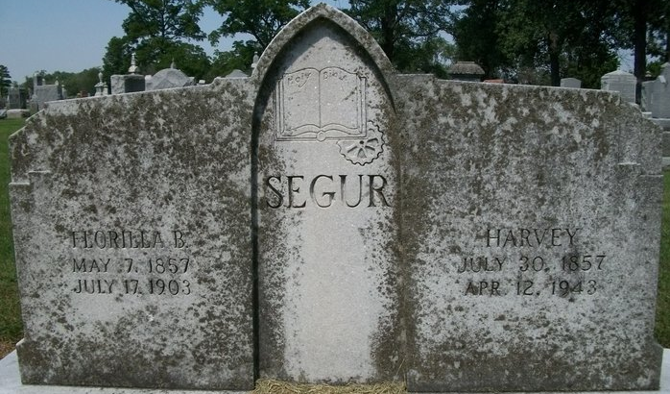
Photo by Deb Curry

Florilla Jeger
in the Indiana, U.S., Death Certificates, 1899-2017
Name Florilla Seger
Race White
Age 46
Marital Status Married
Birth Date 7 May 1857
Birth Place Steuben Co Indiana
Death Date 17 Jul 1903
Death Place Decatur, Adams, Indiana, USA
Death Registration Date 1903
Father Chester Burch
Mother Mary Davis
Spouse Harvery Segur
Informant Harvey Segur; Decatur, Indiana
Burial July 20, 1903; City Cemetery

