Lucille G. (DeBolt) Secaur
August 19, 1915 – November 27, 2004

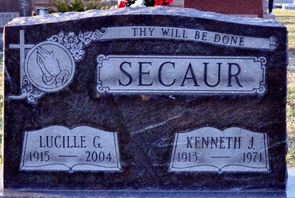
Photo by Deb Curry

Lucille G. Secaur, 89, of Decatur, died on Saturday in Adams Memorial Hospital. She was born in Decatur on August 19, 1915, to Dora and Vella Cook DeBolt. She married Kenneth Secaur on May 19, 1933; he died on February 28, 1971.
She was a homemaker who worked as a saleswoman at the former Habegger-Schafer Hardware store in downtown Decatur. She was a member of Decatur Church of God and was a Sunday School teacher who also held numerous church offices. She was active with Meals on Wheels and as a Cub Scout den mother.
Surviving are two sons, Ronald E. Secaur of Decatur and Nick L. Secaur of Rome City; a sister, Lavon Grice of Decatur; nine grandchildren; and 25 great-grandchildren. A son, two brothers, and two sisters are deceased.
Funeral services will be held at 11 a.m. Tuesday in Decatur Church of God, with burial in Decatur Cemetery. Visiting hours are 4-8 p.m. today in Haggard and Sefton Funeral Home, Decatur, and 10-11 a.m. Tuesday in the church.
Preferred memorials are to the church.

Decatur Daily Democrat; Adams County, Indiana
Monday, November 29, 2004

