Richard Way Scott
July 19, 1902 – October 14, 1980

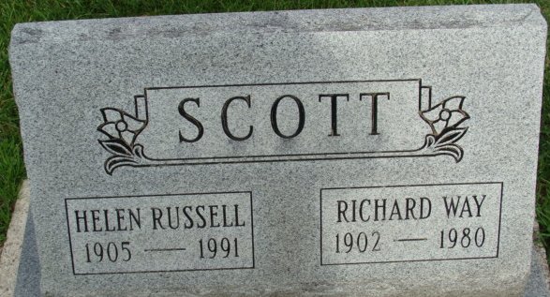
Photo by Alicia Kneuss

Richard W Scott
in the Ohio, U.S., Death Records, 1908-1932, 1938-2022
Name Richard W Scott
Gender Male
Race White
Marital Status Married
Death Age 78
Birth Date Abt 1902
Birth Place Ohio, USA
Residence Place Middletown, Butler, Ohio, USA
Death Date 14 Oct 1980
Death Place Butler, Ohio, USA
Certificate Number 070504
**
Ohio, U.S., County Marriage Records, 1774-1993
Name Richard Scott
Gender Male
Marriage Age 24
Birth Date abt 1903
Marriage Date 16 Apr 1927
Marriage Place Butler, Ohio, USA
Father John Scott
Mother Louise Way
Spouse Helen Russell
Film Number 000355796
**
Richard Way Scott husband of 6thC2xRon FPS in Jones Family Tree
Spouse Helen Russell 6thC2xR on FPS
Father John Scott
Mother Louisa Miles Way
Children Barbara Way
Birth 19 Jul 1902 Lewisville, Monroe, Ohio, USA
Death 14 Oct 1980 Butler, Montgomery, Ohio, USA
Residence 1937 Middletown, Butler, Ohio, USA

