Richard A. Scott
September 27, 1956 – December 3, 2003

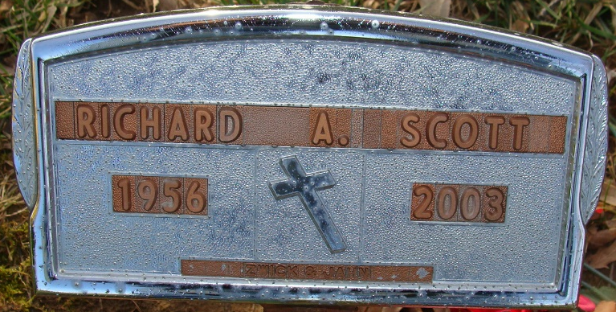
Photo by Alicia Kneuss

Richard A Scott
in the Indiana, U.S., Death Certificates, 1899-2017
Name Richard A Scott
Gender Male
Race White
Age 47
Marital Status Married
Birth Date 27 Sep 1956
Birth Place Ft Wayne, Indiana
Death Date 3 Dec 2003
Death Place Decatur, Adams, Indiana, USA
Death Registration Date 2003
Father Charles Scott
Mother Donna Belle McKenzie
Spouse Janalee Beery
Informant Janalee Scott; wife; Decatur, Indiana
Burial December 8, 2003; Decatur Cemetery; Decatur, Indiana

