Owen A. Scott
July 27, 1916 – August 15, 1999

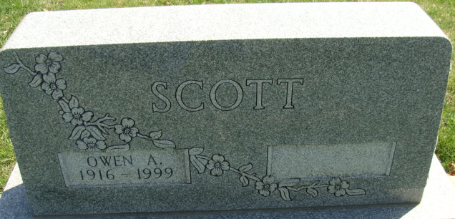
Photo by Alicia Kneuss

Owen A. Scott, 83, of Decatur, a retired farmer, died Sunday, Aug. 15, 1999, at Adams County Memorial Hospital, Decatur. The Van Wert, Ohio, native belonged to Moose Lodge 1311 for 62 years and the Old Timers and Drill Team.
Surviving is a son, Dwight, of Decatur; a daughter, Linda Easterday of Claypool; brothers Avon of Fort Wayne and Carroll of Decatur; a sister, Margaret Kauffman of Decatur; and two grandchildren. A son, Frederick, and a sister, Elizabeth Moser, preceded him in death.
Services are 10 a.m. Wednesday at Haggard & Sefton Funeral Home, Decatur, where calling is from 2 to 5 and 7 to 9 p.m. today, with a Moose memorial service at 8:30 tonight. Burial will be in Decatur Cemetery.
Memorials are to Moose Haven or the American Lung Association.

News-Sentinel, The (Allen County, Indiana)
Tuesday, August 17, 1999

**
Indiana, U.S., Death Certificates, 1899-2017
Name Owen A. Scott
Gender Male
Race White
Age 83
Marital Status Divorced
Birth Date 27 Jul 1916
Birth Place Van Wert, Ohio
Death Date 15 Aug 1999
Death Place Decatur, Adams, Indiana, USA
Death Registration Date 1999
Father Jacob Scott
Mother Eva Pancake
Informant Dwight Scott; son; Decatur, Indiana
Burial August 18, 1999; Decatur Cemetery; Decatur, Indiana

