Margene (Fricke) Scott
September 14, 1936 -

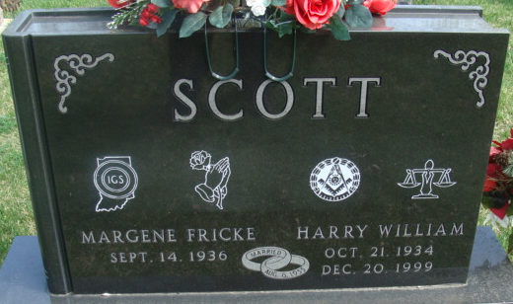
Photo by Alicia Kneuss

