Jacob Earl Scott
December 31, 1887 – March 11, 1953

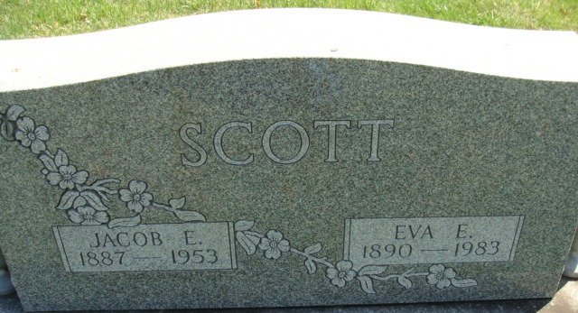
Photo by Alicia Kneuss

Jacob Earl Scott
in the Indiana, U.S., Death Certificates, 1899-2017
Name Jacob Earl Scott
Gender Male
Race White
Age 65
Marital Status Married
Birth Date 31 Dec 1887
Birth Place Allen Co, Indiana
Death Date 11 Mar 1953
Death Place Rural, Adams, Indiana, USA
Death Registration Date 1953
Father Winfield Scott
Mother Margerite Prophet
Informant Mrs. Jacob E. Scott; Decatur, Indiana
Burial March 13, 1953; Decatur Cemetery; Decatur, Indiana

