Helen (Russell) Scott
September 2, 1905 – January 28, 1991

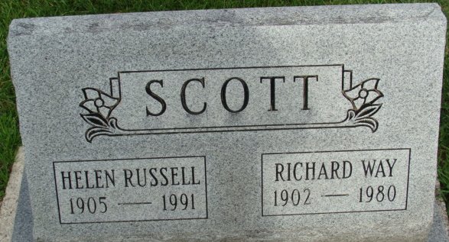
Photo by Alicia Kneuss

Helen Scott
in the Ohio, U.S., Death Records, 1908-1932, 1938-2022
Name Helen Scott
[Helen Russell]
Gender Female
Race White
Marital Status Widowed
Death Age 85
Birth Date 2 Sep 1905
Birth Place Indiana, USA
Residence Place Middletown, Butler, Ohio, USA
Death Date 28 Jan 1991
Death Place Middletown, Butler, Ohio, USA
Death Hospital Other/Residence
Industry Homemaker, Student, Unemployed Volunteer
Occupation Homemaker
Education 11
Filing Date 31 Jan 1991
Father Russell
Certificate Number 000382
**
Ohio, U.S., County Marriage Records, 1774-1993
Name Helen Russell
Gender Female
Marriage Age 21
Birth Date abt 1906
Marriage Date 16 Apr 1927
Marriage Place Butler, Ohio, USA
Father U. S. Russell
Mother Lydia Stelter
Spouse Richard Scott

**
Helen Russell from tree Schoffstoll Family Tree
Birth 2 Sep 1905 Indiana, USA
Residence 1 Apr 1940 Middletown, Butler, Ohio, USA
Death 28 Jan 1991 Middletown, Butler, Ohio, USA
Father Ulysses Grant Russell (1868-1921)
Mother Lydia Stalter (1871-1944)
Spouse Richard Way Scott (1902-1980)

