Harry William Scott
October 21, 1934 – December 20, 1999

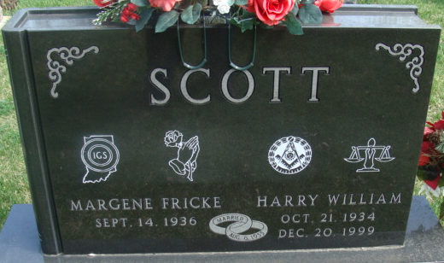
Photo by Alicia Kneuss

Harry W. Scott, 65, of Decatur and formerly of Fort Wayne, died Monday, Dec. 20, 1999, at home. The Chicago native was an attorney, a member of Masonic Lodge 571 F&AM, Scottish Rite, Mizpah Shrine, Adams County Shrine Club, Calleopers and Elks Lodge, past master of Decatur Lodge F&AM and a former president of Indiana County Attorney Association.
Surviving is his wife, Margene F.; a son, Michael B. of Decatur; a daughter, Debra Easterday of Zionsville; a sister, Elizabeth A. Johnson of Atlanta; and four grandchildren.
Services are 11 a.m. Thursday at Haggard & Sefton Funeral Home, Decatur, with calling from 2 to 4 and 6 to 8 p.m. Wednesday with an 8 p.m. Masonic service. Burial will be in Decatur Cemetery.
Memorials are to Decatur Masonic Lodge or National Fragile X Foundation.
Information provided by Haggard and Sefton Funeral Home, Decatur, 1-219-724-7167.

News-Sentinel, The (Fort Wayne, Indiana)
Tuesday, December 21, 1999

**
Indiana, U.S., Death Certificates, 1899-2017
Name Harry W. Scott
Gender Male; Race White
Age 65
Marital Status Married
Birth Date 21 Oct 1934
Birth Place Chicago,IL
Death Date 20 Dec 1999
Death Place Decatur, Adams, Indiana, USA
Father Harry W. Fricke Scott
Mother Margaret E Shugert
Spouse Margene F. Fricke
Informant Margene Scott; wife; Decatur, Indiana
Burial December 23, 1999; Decatur Cemetery; Decatur, Indiana

