Fredrick Allen Scott
October 6, 1950 – March 2, 1953

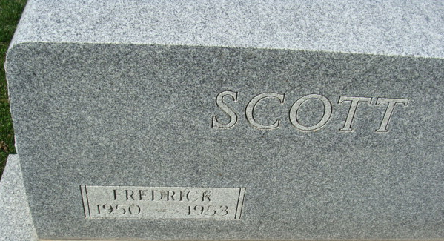
Photo by Alicia Kneuss

Frederick Allan Scott
in the Indiana, U.S., Death Certificates, 1899-2017
Name Frederick Allan Scott
Gender Male
Race White
Age 2
Marital Status Never Married (Single)
Birth Date 6 Oct 1950
Birth Place Decatur Indiana
Death Date 2 Mar 1953
Death Place Decatur, Adams, Indiana, USA
Death Registration Date 1953
Father Owen Scott
Mother Alberta Stump
Informant Owen Scott; Decatur, Indiana
Burial March 5, 1953; Maplewood Cemetery; Decatur, Indiana

