Eva E. (Pancake) Scott
September 21, 1890 – January 2, 1983

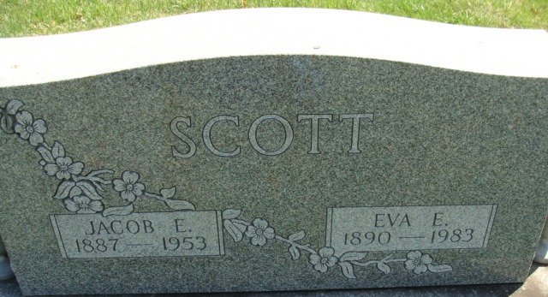
Photo by Alicia Kneuss

Eva E. Pancake
in the Ohio, U.S., Births and Christenings Index, 1774-1973
Name Eva E. Pancake
Gender Female
Race White
Birth Date 21 Sep 1890
Birth Place Harrison, Van Wert, Ohio
Father Abram Pancake
Mother Olive Sheets
FHL Film Number 1015857

**
Ohio, U.S., Death Records, 1908-1932, 1938-2022
Name Eva E Scott
Gender Female
Race White
Marital Status Widowed
Death Age 92
Birth Date Abt 1891
Birth Place Ohio, USA
Death Date 2 Jan 1983
Death Place Mercer, Ohio, USA
Certificate Number 004794
Inquest Hospital Long-Term Care Facilities
Inquest Questions Certifier: Physician; Autopsy Performed?: Yes, Used For Certification;
**
Ohio, U.S., County Marriage Records, 1774-1993
Name Eva E. Pancake
Gender Female
Marriage Age 23
Birth Date abt 1891
Marriage Date 26 Feb 1914
Marriage Place Van Wert, Ohio, USA
Father Abraham Pancake
Mother Olivia Sheets
Spouse Jacob E. Scott
Film Number 001015865

