Elmer K. Scott
June 14, 1918 – September 4, 1978

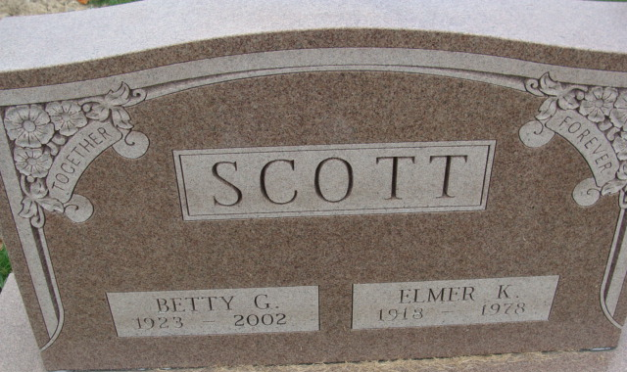
Photo by Alicia Kneuss

Elmer K Scott
in the Indiana, U.S., Death Certificates, 1899-2017
Name Elmer K Scott
Gender Male
Race White
Age 60
Marital Status Married
Birth Date 14 Jun 1918
Birth Place Indiana
Death Date 4 Sep 1978
Death Place Fort Wayne, Allen, Indiana, USA
Death Registration Date 1978
Father Orville Scott
Mother Opal Rider
Spouse Betty G Brown
Informant Betty G. Scott; Decatur, Indiana
Burial September 7, 1978; Decatur Cemetery; Decatur, Indiana

