Dianna R. (DeBolt) Scott
1943 -

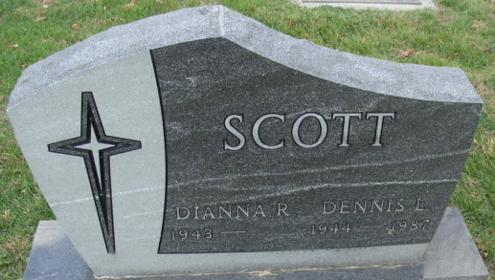
Photo by Alicia Kneuss

