Dennis L. Scott
February 1, 1944 – February 8, 1987

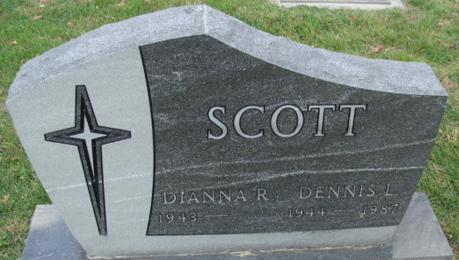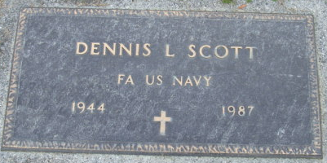
Photo by Alicia Kneuss

Dennis L Scott
in the Indiana, U.S., Death Certificates, 1899-2017
Name Dennis L Scott
Gender Male
Race White
Age 43
Marital Status Married
Birth Date 1 Feb 1944
Birth Place Indiana
Death Date 8 Feb 1987
Death Place Decatur, Adams, Indiana, USA
Death Registration Date 1987
Father Elmer K Scott
Mother Betty G Brown
Spouse Dianna R DeBolt
Informant Dianna R. Scott; wife; Decatur, Indiana
Burial February 10, 1987; Decatur Cemetery; Decatur, Indiana

