Corey L. Scott
December 28, 1968 – February 8, 1997

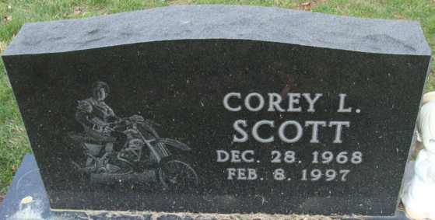
Photo by Alicia Kneuss

Corey L. Scott, 28, Tampa, Florida, died Saturday in Jackson Memorial Hospital, Miami, Florida, of injuries suffered that day in a professional motorcycle stunt accident at the Orange Bowl in Miami.
He was born December 28, 1968 in Fort Wayne to Dennis L. and Dianna R. DeBolt Scott. His father died on January 8, 1987; his mother lives in Decatur.
He was a professional motorcycle stunt performer and was self-employed under the name Scott's Super Stunts. A former employee of Chitwood Chevy Thunder Show at Tampa, he was a member of Carpenter's Union Local 232 in Fort Wayne.
Also surviving are a sister, Mrs. David (Lori L.) Vorhees, (cut off)

Decatur Daily Democrat, Adams County, Indiana
Tuesday, February 11, 1997

