Betty G. (Brown) Scott
August 30, 1923 – August 29, 2002

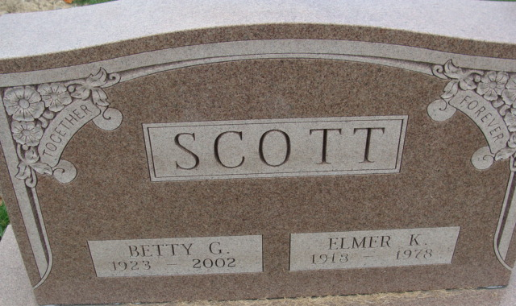
Photo by Alicia Kneuss

Betty G. Scott, 78, of Decatur, a retired administration clerk, died Thursday, Aug. 29, 2002, at Woodcrest Nursing Facility. The Adams County native retired from Automatic Sprinkler in Monroe, had worked for Adams County Memorial Hospital as kitchen staff and drove school bus for five years.
She was a member of Decatur Church of God, director of Bible School, Children's Church, choir member and church secretary. She also taught first grade class at church, substitute teacher for Builder's Class, member of Ladies Prayer group and worked with Meals on Wheels.
Surviving are daughters Sharon Zoss of Tampa, Fla., and Marilyn Alt of Ocean Springs, Miss.; sisters Naomi Mora of Redding, Calif., and Thelma Stauffer of Summerville, S.C.; six grandchildren; and nine great grandchildren. She was preceded in death by her husband, Elmer, sons Dennis and Terry, two sisters and three brothers.
Services are 11 a.m. Tuesday at Decatur Church of God, Decatur, with calling one hour before services. Calling is also from 5 to 8 p.m. Monday at Haggard & Sefton Funeral Home, Decatur. Burial will be at Decatur Cemetery. Memorials are to the church.

News-Sentinel, Allen County, Indiana
Saturday, August 31, 2002

**
Indiana, U.S., Birth Certificates, 1907-1944
Name Betty Brown
Gender Female
Birth Date 30 Aug 1923
Birth Place Decatur, Adams, Indiana, USA
Father Luther Brown; age 42
Mother Mary Edna Presdorf; age 39; 7th child; all living
Certificate Number 39608
Roll number 40474_357316
Volume Range 76 - 80

