Margie (Archer) Scoles
April 1, 1926 – April 12, 2008

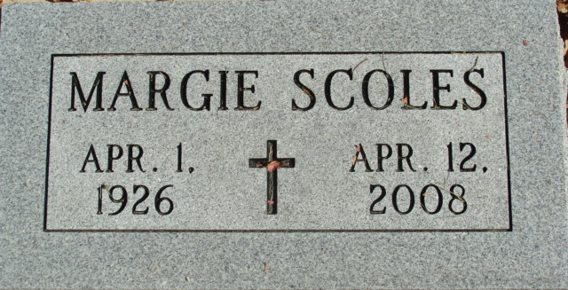
Photo by Alicia Kneuss

Margie Archer Webster Scoles, 82, of Fort Wayne, passed away Saturday, April 12, 2008, at Parkview Hospital. Born April 1, 1926, she was the daughter of the late Mary and Isaac (Ike) Archer. During the 1950's, she waitressed at Fort Wayne's finest restaurants: The Flame, Ted & Toms, Trolley Bar and The Victory Club. She worked 14 years at the Latch String then 14 years at Dairy Queen.
She loved to read murder mysteries. She also loved her dogs. She played solitaire nonstop.
She is survived by her children, Marla (Ron) Miron of Omena, Mich. and Daniel Webster of Concord, Calif. She was also preceded in death by her older sister, Rosemary Archer; and daughter, Sara Jo Firestine- Koljonen.
"Thank you to Canterbury Nursing and Rehabilitation Center. Especially to Debbie and Jeramy at Canterbury. Also, to Cheryl, her mom and dad and all her brothers. Thanks to Don Meyer (landlord) who never raised Margie's rent in 25 years."
No services are planned. "Raise a toast to Margie. She would have liked that."

News-Sentinel, Allen County, Indiana
Wednesday, April 16, 2008

