Roy Gilbert Schwartz
September 23, 1922 – January 30, 2011

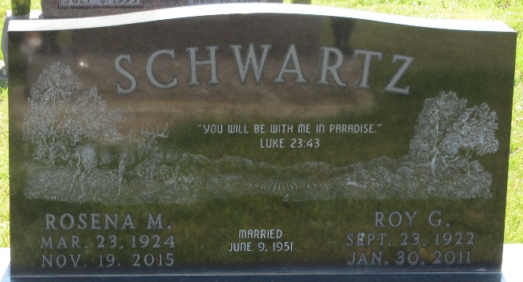
Photo by PLS

Roy Gilbert Schwartz, 88 years old of Decatur, Indiana, passed away at 11:00 p.m. on Sunday, January 30, 2011 in the Adams Memorial Hospital located in Decatur. Roy was born on Saturday, September 23, 1922 in Adams County, Indiana, the son of the late Dan D. Schwartz and the late Leah (Graber)Schwartz. He married Rosena M. Burke on June 9, 1951.
Roy was an elder in the Decatur congregation of Jehovah's Witnesses. He retired from Decatur Industries as Plant Supervisor after 40 years of service.
Surviving is his wife, Rosena M. Schwartz of Decatur, Indiana; sister, Anna (Doyle) Lehman of Berne, Indiana; sister, Jane (Army) Valasco of Berne, Indiana. Preceding Roy in death were two brothers, Melvin and David and one sister, Irene.
Funeral services will be held at 10:30 a.m. Saturday, February 5, 2011 in the Zwick & Jahn Funeral Home with Randy Melching officiating. Interment will follow in the Decatur Cemetery, Decatur, Indiana. Friends will be received from 2-5 and 6-8 p.m. Friday, February 4, 2011 in the Zwick and Jahn Funeral Home, Decatur, Indiana.
Preferred memorials are to Worldwide Work of Jehovah's Witnesses.

Zwick & Jahn Funeral Home, Adams County, Indiana
January 31, 2011

