Rosena Mae (Burke) Schwartz
March 23, 1924 – November 19, 2015

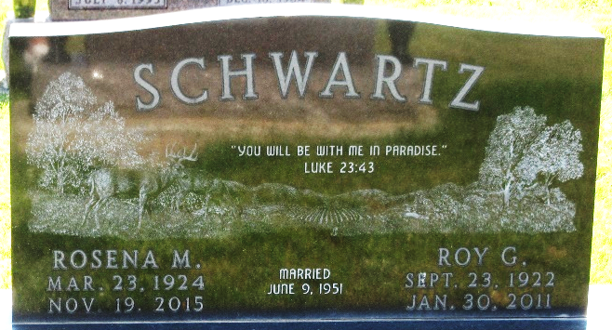
Photo by PLS

Rosena Mae Schwartz, 91, of Decatur, Indiana, passed away on Thursday, November 19, at Woodcrest in Decatur. She was born March 23, 1924, in Adams County, to the late Albert Arthur Burke and the late Grace Mae (Ramsey) Burke. On June 9, 1951, she married Roy G. Schwartz of Berne, Indiana. He preceded her in death on January 30, 2011.
Rosena retired from Decatur Industries with over 40 years of service. She was a longtime member of the Christian Congregation of Jehovah's Witnesses in Decatur, and then in the Bluffton congregation for the last two years.
Worship of her Creator was of utmost importance in Rosena's life. She also enjoyed flower gardening, baking, and was an accomplished seamstress.
She is survived by a sister, Katherine Isch of Decatur, sisters-in-law Anna (Doyle) Lehman and Jane (Army) Velasco, both of Berne, Indiana, and a great many nephews and nieces.
Preceding her in death, besides her parents and husband, were four brothers: Adrian, Verlin, Jesse, and Von; and six sisters: Doris, Evelyn, Lillian, Marjorie, Marian, and Bonnie.
A memorial service will be held Sunday, November 29, 2015, at 4:00 p.m. at the Kingdom Hall of Jehovah's Witnesses, 2803 North Main Street, Bluffton, Indiana, with visitation from 2-4 p.m. at the Kingdom Hall.

Zwick & Jahn Funeral Home, Adams County, Indiana

