Peter D. Schwartz
January 18, 1894 – October 30, 1984

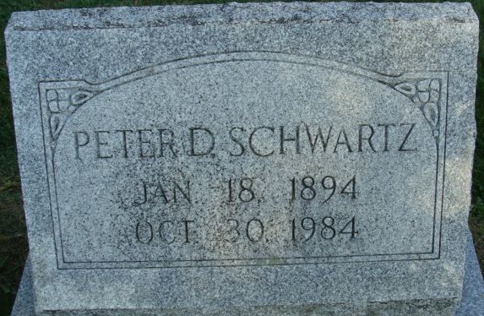
Photo by Alicia Kneuss

Peter D. Schwartz, 90, a resident of the Riverview Care Center, Fort Wayne, for the past four years, died at 6:15 p.m. Tuesday at his residence, following an extended illness.
He was a former employee of the Decatur General Electric Co., a retired Decatur Industries employee and former operator of Schwartz Realty. He lived on West Monroe St. until moving to Fort Wayne and attended the Decatur United Brethren Church.
Born in Adams County on Jan. 18, 1894, he was the son of David D. and Anna Nussbaum-Schwartz and was first married to Elizabeth D. Nussbaum June 18, 1916; she died in November of 1936. He later married Mae Reece Marshall June 21, 1947; she survives and lives at Riverview Care Center.
Survivors also include six children, Gerhart R. Schwartz, Macomb, Ill.; Chester H. Schwartz, Battle Creek, Mich.; LeRoy D. Schwartz, San Bernadino, Calif.; Mrs. E.H. (Frances) Lushbaugh, San Diego, Calif.; Raymond L. Schwartz, Indianapolis; Mr. R. Dale (Rosemary E.) Osborn, Fort Wayne; a sister, Mrs. Martha Graber, Lamar, Mo.; two brothers, Dan D. Schwartz, Berne, and J.D.R. (Jack) Schwartz, Douglas, Mich.; a stepson, Clifford Marshall, Fairbanks, Alaska; a stepdaughter, Mrs. Lester (Mildred) Strahm, Decatur; 20 grandchildren; and 31 great-grandchildren. One daughter, Anna, is deceased.
Services will be held Friday at 10:30 a.m. at the Zwick, Boltz & Jahn Funeral Home, with Rev. Sylvester Martin officiating. Burial will be in the Decatur Cemetery. Friends may call at the (article cut off)

Decatur Daily Democrat, Adams County, Indiana
Wednesday, October 31, 1984

