Mae N. (Reece) Schwartz
March 11, 1906 – May 2, 1988

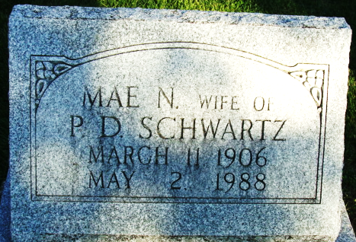
Photo by Alicia Kneuss

Mae N. Schwartz, 82, a resident of Swiss Village, Berne, since April of 1987 and formerly of West Monroe St. in Decatur, died at 4:35 p.m. Monday in Adams County Memorial Hospital.
She attended Decatur United Brethren Church. Born in Willshire, O., on March 11, 1906, she was the daughter of William and Phoebe Gause-Reece, and was married June 21, 1947, in Decatur, to Peter D. Schwartz; he died Oct. 30, 1984.
Survivors include a daughter, Mrs. Lester (Mildred) Marshall Strahm, Decatur; a son, Clifford J. Marshall, Fairbanks, Alaska; four stepsons, Gerhart Schwartz, Battle Creek, Mich.; Chester Schwartz, Battle Creek, Mich.; LeRoy Schwartz, San Berdine, Calif.; Raymond Schwartz, Indianapolis; two stepdaughters, Mrs. Frances Lushbaugh, San Diego, Calif., and Mrs. Dale (Rosemary) Osborne, Fort Wayne; two sisters, Mrs. Lucille Baney, Findlay, O., and Mrs. Dorothy Hurless, Willshire, O.; eight grandchildren; two great-grandchildren; 20 step-grandchildren; and 31 step-great-grandchildren. One stepdaughter, Anna Rodenbeck, and three brothers are deceased.
Services will be held at 10:30 a.m. Friday at Zwick-Sefton & Jahn Funeral Home, Rev. Sylvester Martin officiating. Burial will be in the Decatur Cemetery. Friends may call at the funeral home from 2-4 and 7-9 p.m. Thursday.
Memorials are to Swiss Village or the Decatur Missionary Church.

Decatur Daily Democrat, Adams County, Indiana
Tuesday, May 3, 1988

