Linda L. (Tschannon) Schwartz
February 1, 1952 -

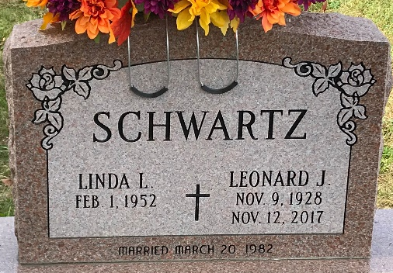
Photo by PLS

