Leonard J. Schwartz
November 9, 1928 – November 12, 2017

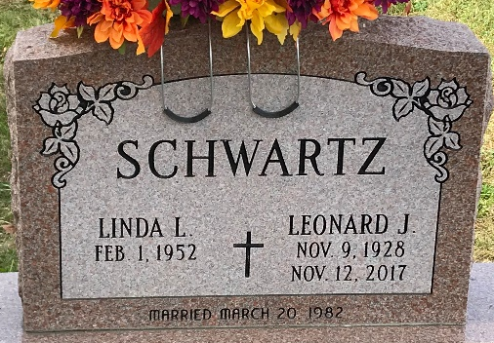
Photo by PLS

Leonard J. Schwartz, 89, of Berne, IN passed away Sunday, November 12, 2017 at Lutheran Hospital. Leonard was born on November 9, 1928 in Berne, IN to the late L. Reuben and Rachael (Steury) Schwartz. On March 20, 1982, he married Linda L. Tschannen.
Leonard worked at Indiana Construction as a carpenter in the 50’s; owned/operated Berne Oil for 30 years; worked for Courtesy Motors as a salesman in the 80’s and then retired in 2005 from Habegger Ace Hardware.
He is survived by his wife of 35 years, Linda L. Schwartz of Berne; three sons, David (Michelle) Schwartz of Ft. Wayne, Raymond Schwartz of Lancaster, Ohio and Joseph (Jose') Schwartz of Lancaster, Ohio; two daughters, Sherry Steiner of Santa Claus, IN and Leslie (D.J.) Ahlfeld of Churubusco, IN; a brother Richard (Janice) Schwartz of Decatur; Jeanette Koomler of Ft. Wayne, Irene (Marvin) Watkins of Decatur, Flossie (Robert) Cable of Auburn; a sister-in-law, Rebecca (James Jr.) Cochran of Decatur; 8 grandchildren and 4 great grandchildren.
He was preceded in death by a sister, Carol Yager.
Visitation will be from 4:00-8:00 p.m. Thursday, November 16, 2017 at Haggard-Sefton & Hirschy Funeral Home. Funeral Services will be held at 11:00 a.m. Friday, November 17, 2017 also at the funeral home, with calling from 10:00 - 11:00 a.m. Pastor Jerry Flueckinger will be officiating.

Haggard & Sefton Funeral Home, Adams County, Indiana
November 13, 2017

