Janice E. (Bixler) Schwartz
August 22, 1948 – December 18, 2021

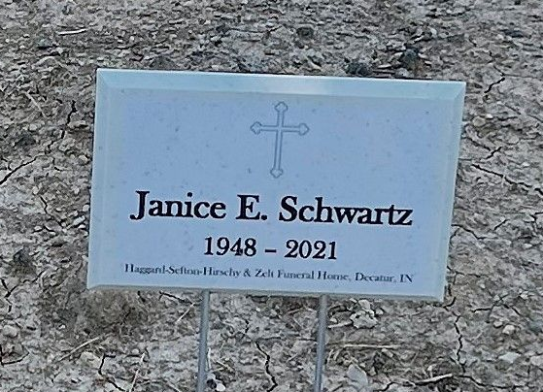
Photo by Deb Curry

Janice Elaine Schwartz, 73, of Decatur, passed away on Saturday, December 18, 2021, at 4:31 a.m. at Adams Memorial Hospital. She was born on August 22, 1948, daughter of Virgil L. Bixler and the late Garnett Maxine (Herman) Bixler. Janice was united in marriage, at the Decatur Missionary Church, to Richard L. Schwartz on June 11, 1966.
She was a member of Decatur Missionary Church and loved watching Dr. Charles Stanley on Sunday mornings. Janice graduated from Decatur High School, Class of 1966. She was a homemaker and worked for ARC (Bi-County Services) of Bluffton, Indiana.
Janice loved to travel, especially to Pigeon Forge, Tennessee, Siesta Keys, Florida and Branson, Missouri. She enjoyed going out to eat, loved putting together flower arrangements and doing crafts. Janice also loved watching Hallmark movies and listening to music, especially Elvis. She always had a smile on her face and would go out of her way to help anyone.
Janice is survived by her father, Virgil L. Bixler of Decatur; her husband of 55 years, Richard L. Schwartz of Decatur; a daughter, Stephanie (Scott) Cox of Decatur; a son, Steven Schwartz of Decatur; a brother, Roger L. Bixler of Decatur; a sister, Betty J. Bixler of Decatur; one niece and two nephews. She was preceded in death by her mother, Garnett Bixler.
Visitation will be from 4:00 – 8:00 p.m. on Wednesday, December 22, 2021, at Haggard-Sefton-Hirschy & Zelt Funeral Home.
A Funeral Service will be held at 11:00 a.m. on Thursday, December 23, 2021, with a visitation one hour prior to the service, also at the funeral home. Rev. Steve Bard will be officiating and burial will follow in Decatur Cemetery.
Memorials may be made to St. Jude Children’s Hospital.

Haggard & Sefton Funeral Home, Adams County, Indiana
December 18, 2021

