Elizabeth D. (Nussbaum) Schwartz
September 20, 1893 – November 19, 1936

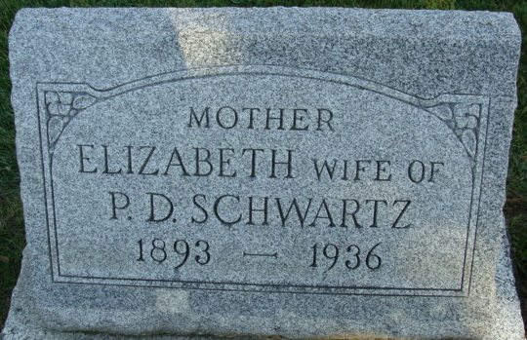
Photo by Alicia Kneuss

DEATH CLAIMS MRS. SCHWARTZ
Mrs. Peter D. Schwartz Dies at Monroe Township Home
Mrs. Elizabeth Schwartz, aged 43, wife of Peter D. Schwartz, died at her home in Monroe Township Thursday afternoon at 4 o'clock. Death was due to complications. The deceased had been ill for the past 10 weeks. She was born in Wabash Township on September 20, 1893, the daughter of David and Maria Nussbaum. the father is still living, the mother having preceded her in death.
Surviving besides the husband are the following children: Gerhart, Chester, LeRoy, Frances, Raymond, Rosemary and Anna, all at home.
Four brothers, Samuel, Jacob, Phillip and Menno, all of the Berne community, also survive.

Decatur Daily Democrat, Adams County, Indiana
Friday, November 20, 1936

**
MRS. SCHWARTZ DIES THURSDAY
Funeral Service for Local Woman is on Sunday Afternoon
Mrs. Elizabeth D. Schwartz, age 43, wife of Peter D. Schwartz of northeast Berne residing on the Benjamin Habegger farm, passed away Thursday afternoon at 3:50 o'clock. She had been critically ill for about ten weeks and during the past week little hope was held for recovery. Death was caused by carcinoma.
The deceased was born September 20, 1893, a daughter of Mr. and Mrs. David C. Nussbaum. She was a lifelong resident of this community.
June 18, 1916 she was married to Peter D. Schwartz who survives with the following children: Gerhart R., Chester H., LeRoy D., Frances M., Raymond L., Anna Louise and Rosemary Elizabeth.
Brothers and sisters who survive are Samuel, Jacob, Philip and Menno Nussbaum, all of this community. One sister preceded.
Funeral services will be held Sunday afternoon at 1:30 o'clock at the home and at 2:00 o'clock at a church to be announced later.

Adams County (IN) Historical Museum
1936 Scrapbook, image 70
Handwritten date: Friday, November 20, 1936
**

SCHWARTZ RITES SUNDAY
Funeral services for Mrs. Peter D. Schwartz Held Here
Funeral services were held Sunday afternoon at 2 o'clock at the Mennonite Church for Mrs. Peter D. Schwartz, aged 43, who died at her home late Thursday. Rev. C. H. Suckau officiated at the services. The funeral sermon was preached in German. Burial was in the M.R.E. Cemetery.
Mrs. Schwartz had been ill for ten weeks, and her condition was critical for several days before her death. A postmortem held Friday disclosed that death was caused by carcinoma. She suffered greatly during her illness.
The Schwartz family lives on the former Ben Habegger farm, northeast of Berne.
Elizabeth Nussbaum Schwartz was born in Wabash township, Sept. 20, 1893, a daughter of David C. and Marian Habegger Nussbaum. Most of her life was spent in Monroe township, and on June 18, 1916, she was married to Peter D. Schwartz.
He survives and the following children, all at home: Gerhart, Chester, Leroy, Frances, Raymond, Anna Louise and Rosemary Elizabeth. The father, David C. Nussbaum, also survives, and four brothers, Sam D., Jacob, Philip and Menno Nussbaum, all of this community. The step-grandmother survives, Mrs. Catherine Habegger. The mother and one sister preceded.

Adams County (IN) Historical Museum
1936 Scrapbook, image 70
Handwritten date: Monday, Nov. 23, 1936
**

CARD OF THANKS
We, the undersigned, wish to express our sincere thanks and appreciation to our neighbors, relatives and friends, who assisted us during the sickness and death of our beloved wife and mother. We also wish to thank all those who expressed their sympathy in any way, and to those who brought food, or other articles. We also wish to thank those who brought floral offerings.
Peter D. Schwartz and family.
Adams County Historical Museum, Adams County, Indiana
1936 Scrapbook, image 70
Handwritten date: Monday, Nov. 23, 1936

