Oran Leo Schultz
November 5, 1905 – July 24, 1983

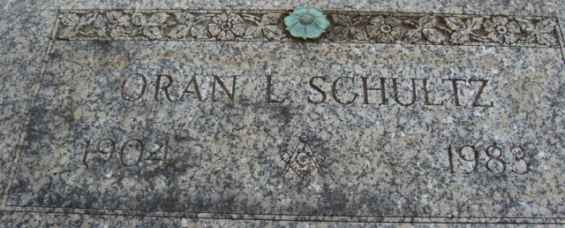
Photo by Alicia Kneuss

Oran L. Schultz
in the Indiana, U.S., Death Certificates, 1899-2017
Name Oran L. Schultz
Gender Male
Race White
Age 77
Marital Status Married
Birth Date 5 Nov 1905
Birth Place Indiana
Death Date 24 Jul 1983
Death Place Fort Wayne, Allen, Indiana, USA
Death Registration Date 1983
Parents Unknown
Spouse Evelyn Jacobs
Informant Mrs. Oran Schultz; Decatur, Indiana
Burial July 27, 1983; Decatur Cemetery
**
Oran Leo Schultz from tree Families From Our Past
Birth 1905 Indiana, USA
Residence 1957 Decatur, Adams, Indiana, USA
Marriage 30 Aug 1975 Fort Wayne, Allen, Indiana, USA
Death 1983 Decatur, Adams, Indiana, USA
Father Adam Adolph Schultz (1884-1922)
Mother Clara (1886-1973)
Spouse Evelyn Mae Jacobs (1920-2009)
1609 People 12 Records 12 Sources

