John H. Schultz
December 20, 1879 – June 10, 1961

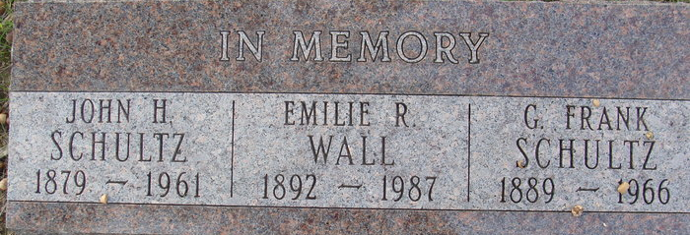
Photo by Alicia Kneuss

John H Schultz
in the Indiana, U.S., Death Certificates, 1899-2017

Name John H Schultz
Gender Male
Race White
Age 81
Marital Status Married
Birth Date 20 Dec 1879
Birth Place Ft Wayne, Indiana
Death Date 10 Jun 1961
Death Place Fort Wayne, Allen, Indiana, USA
Death Registration Date 1961
Father Henry Schultz
Mother Christina Baker
Informant Anna L Schultz; spouse; Fort Wayne, Indiana
Burial June 13, 1961; Elm Grove Cemetery; Bluffton, Indiana

Note: This is a cenotaph – buried in Elm Grove Cemetery, Wells County

