Henry Schultz
December 29, 1852 – March 31, 1924

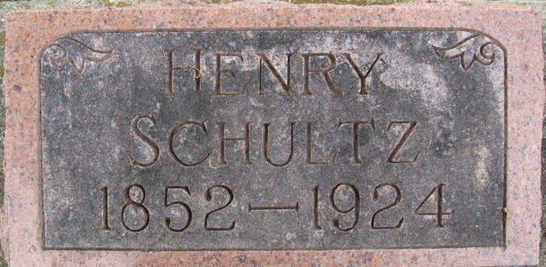
Photo by Alicia Kneuss

Henry Schultz
in the Indiana, U.S., Death Certificates, 1899-2017
Name Henry Schultz
Gender Male
Race White
Age 71
Marital Status Married
Birth Date 29 Dec 1852
Birth Place Indiana
Death Date 31 Mar 1924
Death Place Decatur, Adams, Indiana, USA
Death Registration Date 1924
Father Harvey Schultz
Mother Catherine Ehret
Spouse Christina
Informant Mrs. Clara Hanna; Fort Wayne, Indiana
Burial April 2, 1924; Decatur Cemetery

