Hazel A. (Jackson) Schultz
February 4, 1908 – August 12, 1969

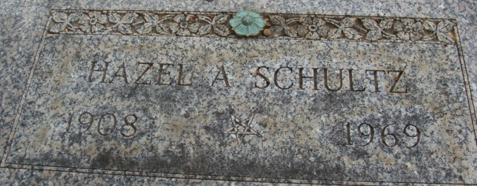
Photo of Alicia Kneuss

MRS. HAZEL A. SCHULTZ
DECATUR – Mrs. Hazel A. Schultz, 61, of Rt. 4, Decatur, died unexpectedly at 9:15 a.m. Tuesday at her residence. Born Feb. 4, 1908, in Mercer County, the daughter of Lewellyn and Emma C. (Kiggins) Jackson.
Mrs. Schultz was a member of the First Christian Church of Decatur and served as the first deputy surveyor for Herman Moellering from 1958 to 1967. She was a member of the Women of the Moose and had served as past senior regent of the organization; the Garden Club; president of the Lady Elks; The Adams County Home Economics Club; Order of the Eastern Star and Daughters of the Nile.
Her marriage to Oren L. Schultz, who survives, was solemnized April 17, 1927. Also surviving are several nieces and nephews.
She was preceded in death by a sister and three brothers.
Funeral services will be at 2 p.m. Saturday at the Winteregg-Linn Funeral Home in Decatur with the Rev. Travis Chandler and the Rev. Kenneth Cook officiating. Burial will be in Decatur Cemetery. Friends may call at the funeral home after 3 p.m. Thursday.

Van Wert Times Bulletin, Van Wert County, Ohio
Wednesday, August 13, 1969

**
Hazel A. Schultz Dies Unexpectedly
Mrs. Hazel A. Schultz, 61, wife of Oran L. Schultz, prominent in civic and social circles, died unexpectedly at 9:15 a.m. Tuesday at her home on Decatur Route 4. Although she had been in failing health for some time, death was sudden.
She was born in Mercer County, O., Feb. 4, 1908, a daughter of Llewellyn and Emma C. Kiggins-Jackson, and was married to Oran L. Schultz April 17, 1927.
She was employed as Deputy County Surveyor for Herman Moellering from 1958 until 1967.
Mrs. Schultz was a member of the First Christian Church, the Women of the Moose, of which she was a past senior regent, the Garden Club, Adams County Home Economics Club, Order of Eastern Star, Daughters of the Nile, and was a past president of the Emblem Club of the Elks Ladies.
Surviving is her husband and several nieces and nephews. One sister and three brothers are deceased.
Funeral services will be conducted at 2 p.m. Saturday at the Winteregg-Linn Funeral Home, with Rev. Kenneth Cook and Rev. Travis Chandler officiating. Burial will be in the Decatur Cemetery.
Decatur Daily Democrat, Adams County, Indiana
Wednesday, August 13, 1969

