George Franklin Schultz
November 7, 1889 – February 8, 1966

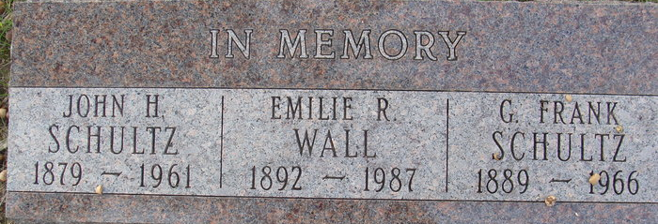
Photo by Alicia Kneuss

George Franklin Schultz
in the Indiana, U.S., Marriages, 1810-2001
Name George Franklin Schultz
Gender Male
Race White
Age 30
Event Type Marriage Registration (Marriage)
Birth Date 7 Nov 1889
Birth Place Poe, Indiana
Marriage Date 19 Jul 1919
Marriage Place Indiana, United States
Residence Place Decatur, Indiana
Father Henry Schultz
Mother Christina Baker
Spouse Clara Louise Boknecht
Officiator Will Hammell
Page 535
**
Ohio, U.S., Death Records, 1908-1932, 1938-2022
Name G F Schultz [George Franklin Schultz]
Gender Male
Race White
Marital Status Married
Death Age 76
Birth Date Abt 1890
Residence Place Akron, Summit, Ohio, USA
Death Date 8 Feb 1966
Death Place Akron, Summit, Ohio, USA
Certificate Number 15059
Inquest Hospital Public - Other
Inquest Questions Certifier: Physician; Autopsy Performed?: Yes, Used For Certification

