Christina (Baker) Schultz
January 28, 1858 – October 17, 1932

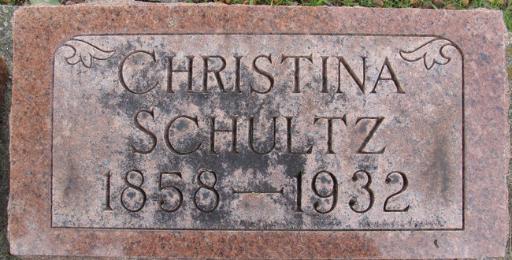
Photo by Alicia Kneuss

Christina Schultz
in the Indiana, U.S., Death Certificates, 1899-2017
Name Christina Schultz
[Christina Baker]
Gender Female
Race White
Age 74
Marital Status Widowed
Birth Date 28 Jan 1858
Birth Place Germany
Death Date 17 Oct 1932
Death Place Decatur, Adams, Indiana, USA
Death Registration Date 1932
Father Adam Baker
Mother Christina
Informant G. Frank Schultz; Akron, Ohio
Burial October 19, 1932; Decatur Cemetery

