Bertha Viola Schultz
January 22, 1896 – March 31, 1916

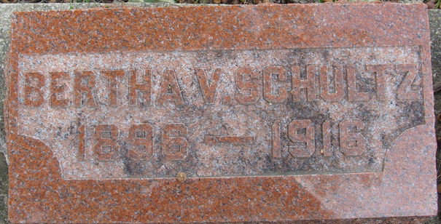
Photo by Alicia Kneuss

Bertha Viola Schultz
in the Indiana, U.S., Death Certificates, 1899-2017
Name Bertha Viola Schultz
Gender Female
Race White
Age 19
Marital Status Single
Birth Date 22 Jan 1897
Birth Place Poe, Indiana
Death Date 31 Mar 1916
Death Place Decatur, Adams, Indiana, USA
Death Registration Date 1916
Father Henry Schultz
Mother Baker
Informant Frank Schultz; Decatur, Indiana
Burial: April 3, 1916; Decatur Cemetery

