Adam Adolph Schultz
March 26, 1884 – March 29, 1922

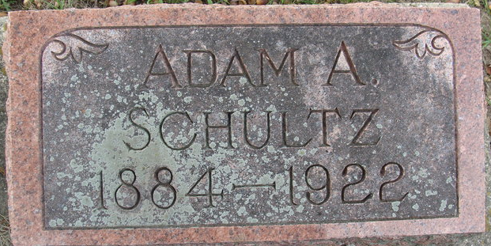
Photo by Alicia Kneuss

OBITUARY

Adam Adolph Schultz, son of Mr. and Mrs. Henry Schultz was born March 26, 1884 in Wells County, Ind., and died March 29, 1922 in this city, aged 38 years and 3 days. His sickness was of long duration, but for the past five or six months has suffered from complications.
He was a member of the Christian Church of this city.
He leaves his father and mother; two brothers, Frank of Akron, Ohio and John of Bluffton, Ind., three sisters, Clara Hanna and Dorothy Helm of Fort Wayne, Indiana, and Emily of Cleveland, Ohio; three nephews, Orion Schultz of this city, and Richard and Donald Helm of Fort Wayne. One sister, Bertha, preceded him in death.

Decatur Daily Democrat; Adams County, Indiana
April 3, 1922

**
LIFE IS ENDED
Adam Schultz Passed Away This Afternoon at the Home of Parents
HIS DEATH RESULTED
From Complications Caused by Epileptic Condition-Well Known.

Adam Schultz, aged 35 years, well-known young man of this city passed away shortly after noon today at the home of his parents, Mr. and Mrs. Henry Schultz on Patterson Street. The young man had been confined at home for the past five or six months suffering from a complication of diseases brought on by an epileptic condition.
The deceased was born in Allen County, near Echo, on March 26, 1887 [sic]. When he was very young the parents moved to this city and have resided here since that time.
Besides the parents, the deceased is survived by three sisters, Mrs. Clara Hanna and Mrs. Dora Heim, residing in Fort Wayne, Miss Emma of Cleveland, Ohio, and two brothers, John Schultz of Bluffton and Frank Schultz of Akron, Ohio.
No funeral arrangements have as yet been made, pending the arrival of the brothers and sisters.

Decatur Daily Democrat, Adams County, Indiana
Wednesday, March 29, 1922

**
Adam Adolph Schultz from faulkner Family Tree
Birth 26 Mar 1884 Indiana, USA
Residence 1920 Decatur, Adams, Indiana, USA
Death 1922 Decatur, Adams, Indiana, USA
Father Henry Charles Augustus Schultz (1852-1924)
Mother Christina BAKER (1858-1932)
Spouse Clara SCHULTZ (1886-1973)

