Frederick H. Schulte
October 4, 1843 – February 25, 1926

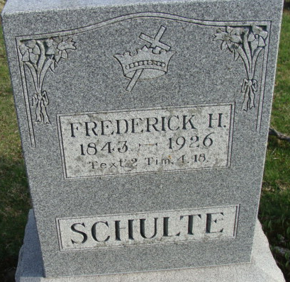
Photo by Alicia Kneuss

Fred H. Schuller
in the Indiana, U.S., Death Certificates, 1899-2017
Name Fred H. Schultie
Gender Male
Race White
Age 82
Marital Status Widowed
Birth Date 4 Oct 1843
Birth Place Germany
Death Date 25 Feb 1926
Death Place Decatur, Adams, Indiana, USA
Death Registration Date 1926 - 1927
Father John H Schulte
Mother Unknown
Informant Henry Schulte; Decatur, Indiana
Burial February 28, 1926; Decatur Cemetery

