John H. Schug
September 11, 1868 – November 11, 1932

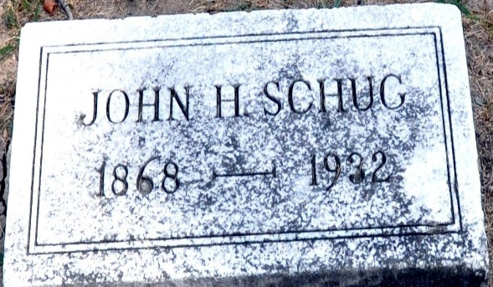
Photo by Deb Curry

John Sching
in the Indiana, U.S., Death Certificates, 1899-2017
Name John Schug
Gender Male
Race White
Age 64
Marital Status Married
Birth Date 11 Sep 1868
Birth Place Indiana
Death Date 11 Nov 1932
Death Place Decatur, Adams, Indiana, USA
Death Registration Date 1932
Father Carl Schug
Mother Catherine Rauch
Spouse Effie
Informant Gerald H. Somers
Burial November 14, 1932; Decatur Cemetery

