George Woodward Schug, Jr.
August 26, 1927 – August 26, 1927

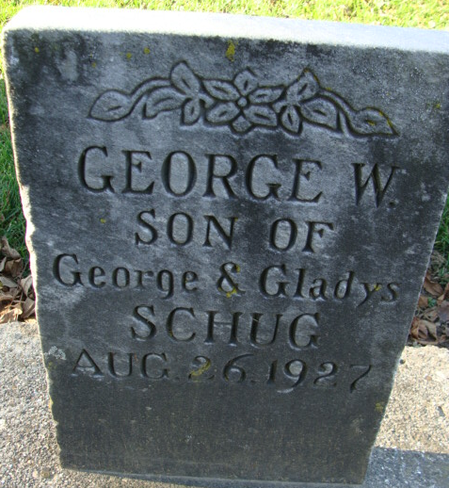
Photo by Alicia Kneuss

George Woodward Schug Jr
in the Indiana, U.S., Death Certificates, 1899-2017
Name George Woodward Schug Jr
Gender Male
Race White
Age 1 hour
Birth Date 26 Aug 1927
Birth Place Indiana
Death Date 26 Aug 1927
Death Place Decatur, Adams, Indiana, USA
Death Registration Date 1926 - 1927
Father George W. Schug
Mother Gladys Butler
Informant John H. Schug
Burial: August 27, 1927; Decatur Cemetery; Decatur, Indiana

