Effie Luretta (Woodward) Schug
February 17, 1880 – July 8, 1941

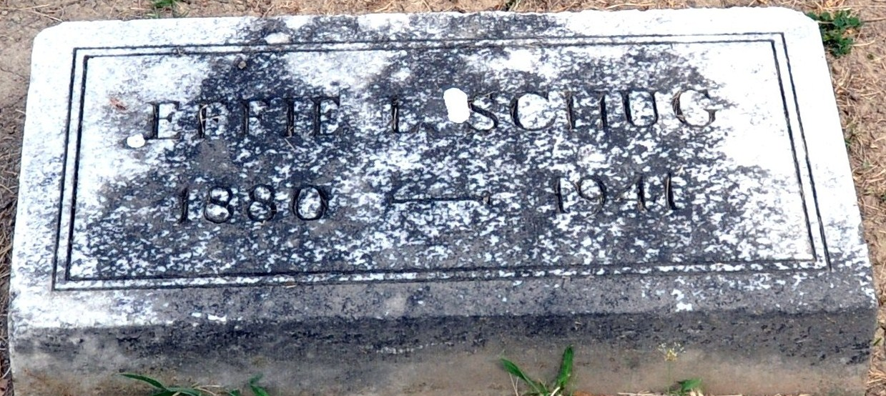
Photo by Deb Curry

MRS. SCHUG IS TAKEN BY DEATH
Mrs. John Schug Dies This Afternoon At Fort Wayne Hospital
Mrs. Effie Woodard-Schug, 61, prominent Decatur lady and widow of the late John Schug, died this afternoon (Tuesday) at 1:47 o'clock at the Lutheran hospital in Fort Wayne.
The attending physician attributed death to uremia. She had been in ill health for some time and was taken to the Fort Wayne hospital Saturday night when her condition became serious.
She was born in this city, the daughter of Mr. and Mrs. George Woodard, and resided here her entire life. She was a member of the First Presbyterian church.
Surviving are three children; George Schug of Roanoke, Virginia; Mrs. Arthur Ambler of Washington, D.C. and Dr. Richard Schug of Selfridge Field, Mt. Clemens, Michigan. A brother, Charles Woodard of Ashland, Wisconsin, also survives.
Funeral services for Mrs. John Schug, will be held Thursday afternoon at 2:30 o'clock at the Presbyterian church, with Rev. G. O. Walton officiating. Burial will be in the Decatur cemetery. The body was to be returned to the residence from the Zwick funeral home this afternoon and may be viewed there until time for the services.

Adams County, Indiana Historical Museum
1941b Scrapbook
Handwritten-July 8, 1941
**
MRS. JOHN SCHUG DIES TUESDAY
FUNERAL FOR WIDOW OF FORMER LOCAL MAN IS THURSDAY P.M.
Mrs. Effie Woodard-Schug, 61, prominent Decatur lady and widow of the late John Schug, died this afternoon (Tuesday) at 1:47 o'clock at the Lutheran hospital in Fort Wayne. Mr. Schug died November 11, 1932
The attending physician attributed death to uremia. She had been in ill health for some time and was taken to the Fort Wayne hospital Saturday night when her condition became serious. Previously she was a patient in the Ford Hospital in Detroit.
She was born in Decatur, February 17, 1880, the daughter of Mr. and Mrs. George Woodard, and resided here her entire life. She was a member of the First Presbyterian church.Mrs. John Schug has been a member of the Board of Directors of the Berne Mfg. Co., since the death of her husband. She was active in various civic groups in Decatur for many years.
Surviving are three children; George Schug of Roanoke, Virginia; Mrs. Arthur Ambler of Washington, D.C. and Dr. Richard Schug of Selfridge Field, Mt. Clemens, Michigan. A brother, Charles Woodward of Ashland, Wis. also survives.The body was returned to Decatur by the Zwick funeral home this afternoon.
Funeral services will be conducted Thursday afternoon at 2:30 o'clock at the Decatur Presbyterian Church, with Rev. G. O. Walton officiating. Burial will be in the Decatur cemetery.
Adams County, Indiana Historical Museum
1941 Aug-Oct Scrapbook, Image 95
Handwritten-July 9, 1941
**
Indiana, U.S., Death Certificates, 1899-2011
Name: Effie Loretta Schug
[Effie Loretta Woodward]
Gender: Female
Race: White
Age: 61
Marital status: Widowed
Birth Date: 17 Feb 1880
Birth Place: Decatur, Ind
Death Date: 8 Jul 1941
Death Place: Fort Wayne, Allen, Indiana, USA
Father: George Woodward
Mother: Mary Ann Stoneburner
Informant: Dr. Richard H. Schug; Henry Ford Hospital, Detroit, Mich.
Burial: July 10, 1941; Decatur Cemetery; Decatur, Indiana

