Mother Schroeder

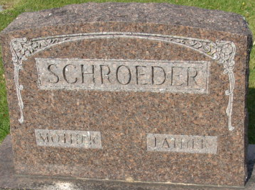
Photo by Alicia Kneuss

