Lawrence T. Schroeder
September 15, 1909 – June 11, 1970

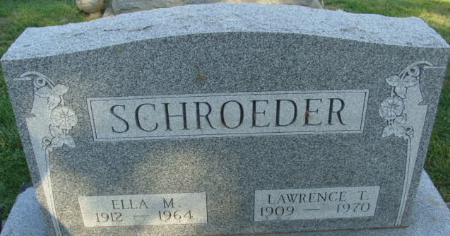
Photo by Alicia Kneuss

Lawrence Schroeder Dies at Hospital

Lawrence T. Schroeder, 60, of 827 Walnut Street, died at 4:30 p.m. Thursday at the Adams County Memorial Hospital, where he had been a patient since March 6. He had been in failing health for 10 months.
He was born in Marion Township, Allen County, Sept. 15, 1909, a son of Charles and Caroline Droege-Schroeder, and was married to Ella Bultemeier Sept. 22, 1936. His wife preceded him in death July 24, 1964.
Mr. Schroeder was employed as a setup mechanic in the winding department of the General Electric Co. for 28 years until ill health forced his retirement.
He was a member of the Zion Lutheran Church.
Surviving are two daughters, Mrs. Fred (Dolores) Macke of Decatur Route 2, and Mrs. Allen (Alice) Scheiderer of Decatur; four sisters, Mrs. Helen Conrad of Decatur, Mrs. Melvin (Olga) Scherer of Hoagland Route 1, Mrs. Simeon (Gertrude) Dettmer of Fort Wayne, and Mrs. Wilfred (Margaret) Scherer of Decatur Route 2; one brother, Paul R. Schroeder of Decatur Route 1; and three grandchildren. One brother and one sister are deceased.
Funeral services will be conducted at 1:30 p.m. Sunday at the Zwick Funeral Home and at 2 p.m. t the Zion Lutheran Church, with Rev. Richard C. Ludwig officiating. Burial will be in the Decatur Cemetery. Friends may call at the funeral home after 7 p.m. today until time of the services.

Decatur Daily Democrat, Adams County, Indiana
Friday, June 12, 1970

