Helen Schroeder

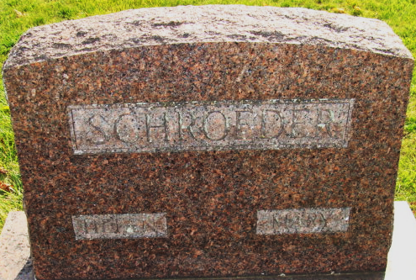
Photo by Alicia Kneuss

