Father Schroeder

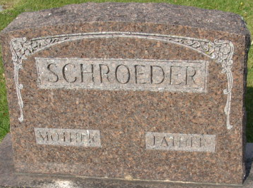
Photo by Alicia Kneuss

