Ella M. (Bultemeier) Schroeder
September 25, 1912 – July 24, 1964

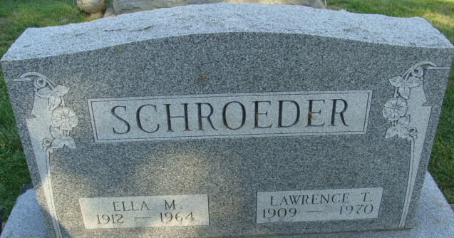
Photo by Alicia Kneuss

Mrs. Ella Schroeder Is Taken by Death

Mrs. Ella Schroeder, 51, wife of Lawrence T. Schroeder, of 827 Walnut Street, died at 1:20 o’clock Friday afternoon at the Adams County Memorial Hospital. She had been in failing health for some time, and seriously ill for the past two weeks.
She was born in Preble Township, Sept. 25, 1912, a daughter of Gustave and Anna Wefel-Bultemeier and was married to Lawrence T. Schroeder Sept. 12, 1937.
Mrs. Schroeder, an employee of the Fairway Restaurant, was a member of the Zion Lutheran Church of Decatur and the Needle Club of the church.
Surviving is her husband; her mother, Mrs. Anna Bultemeier of Madison township, Allen County; two daughters, Mrs. Frederick (Dolores) Macke of Decatur route 2, and Miss Alice Jane Schroeder, at home; two grandchildren; one brother, Lorenz Bultemeier of Madison Township, Allen County, and two sisters, Mrs. Oscar (Clara) Ewell of Preble, and Mrs. Theodore (Esther) Bulmahn of Preble Township. One brother is deceased.
Funeral services will be conducted at 1:30 p.m. Monday at the Zwick Funeral Home, and at 2 p.m. at the Zion Lutheran Church, with the Rev. Richard C. Ludwig officiating. Burial will be in the Decatur Cemetery. Friends may call at the funeral home after 7 p.m. today until time of the services.

Berne Library Heritage Room, Adams County, Indiana
Adams County Obits 1962-1964
Handwritten date: Saturday, July 25, 1964

**
Indiana, U.S., Death Certificates, 1899-2017

Name Ella Schroeder
[Ella Bultemeier]
Gender Female
Race Caucasian (White)
Age 51
Marital Status Married
Birth Date 25 Sep 1912
Birth Place Indiana
Death Date 24 Jul 1964
Death Place Decatur, Adams, Indiana, USA
Death Registration Date 1964
Father Gustave Bultemeier
Mother Anna Wefel
Informant Lawrence P Schroeder; husband; Decatur, Indiana
Burial July 27, 1964; Decatur Cemetery; Decatur, Indiana

