William P. Schrock, Sr.
February 20, 1878 – December 29, 1954

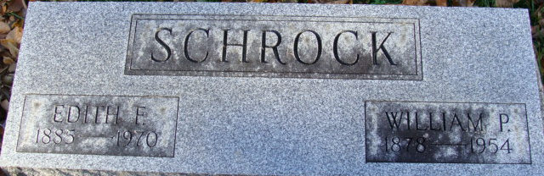
Photo by Alicia Kneuss

William P Schrock Sr
in the Indiana, U.S., Death Certificates, 1899-2017
Name William P Schrock Sr
Gender Male
Race White
Age 76
Marital Status Married
Birth Date 20 Feb 1878
Birth Place Indiana
Death Date 29 Dec 1954
Death Place Decatur, Adams, Indiana, USA
Death Registration Date 1954
Father Dr. Wm H Schrock
Mother Annette Patterson
Informant: Mrs. Wm. Schrock; Decatur, Indiana
Burial: January 1, 1955; Decatur Cemetery; Decatur, Indiana

