William P. Schrock, Jr.
May 19, 1917 – June 26, 2003

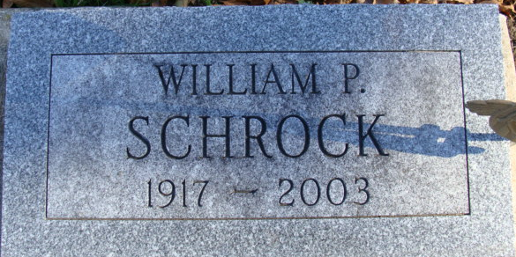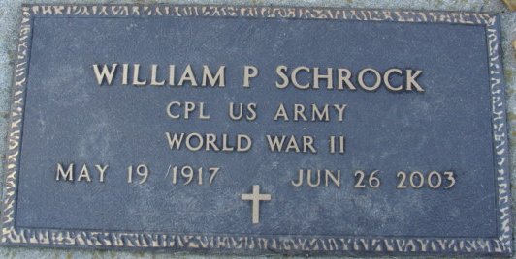
Photo by Alicia Kneuss

Decatur IN – William P. Schrock, 86, of Decatur, died Thursday, June 26, 2003 at Woodcrest Nursing Center.
Surviving are sister, Mrs. Janet (A.W.) Kettler of Fort Wayne, and nephew, Andrew Kettler of New York, N.Y.
Graveside service is 2 p.m. Monday, with military rites by Adams Post #43 color guard. Burial at Decatur Cemetery.

News-Sentinel, Allen County, Indiana
June 28, 2003
**
Indiana, U.S., Death Certificates, 1899-2017
Name William P Schrock
Gender Male
Race White
Age 86
Marital Status Never Married (Single)
Birth Date 19 May 1917
Birth Place Decatur, Indiana
Death Date 26 Jun 2003
Death Place Decatur, Adams, Indiana, USA
Death Registration Date 2003
Father William P Schrock
Mother Edith Smith
Informant: Janet Kettler; sister; Fort Wayne, Indiana
Burial: June 30, 2003; Decatur Cemetery; Decatur, Indiana

