Dr. William Harrison Schrock
February 3, 1841 – October 24, 1886

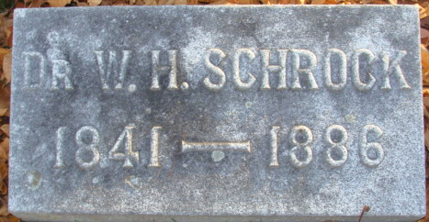
Photo by Alicia Kneuss

William H Schrock
in the Indiana, U.S., Wills and Probate Records, 1798-1999
Name William H Schrock
Gender Male
Residence Date Abt 1886
Residence Place Adams, Indiana
Will Date 30 Jan 1886
Probate Date 6 Nov 1886
Probate Place Adams, Indiana, USA
Death Date October 24, 1886
Inferred Death Place Indiana, USA
Case Number 360
Item Description Will Record, Vol A-C, 1839-1899
Wife: Nettie
Sons: Wm. P. and Robert D. Schrock

**
Indiana, U.S., Marriage Index, 1800-1941
Name W. H. Schrock
Marriage Date 31 May 1870
Marriage Place Adams, Indiana, USA
Spouse Name Nettie M Patterson

**
William Harrison Schrock
By Andria Keller
William H. Schrock was born on February 3, 1841 and lived in Blendon Township in his younger years. He was born to parents William Schrock III and Elizabeth Gulic Schrock who produced fourteen children including 7th child, William H. Schrock. The names of his siblings are as follows; Nancy, Mary, Ephram, Joseph, Martha, Matilda, Henry, Homer, Elizabeth, Rosetta, Walter, Ida, and Zelpha. William’s uncle, George Schrock, was a well-known farmer for whom Schrock Rd. in Westerville, Ohio is named.
William took scientific courses at the Martin Boehm Academy where he graduated in 1862. Shortly after his graduation William decided to enlist in the military on August 6, 1862 but officially mustered into the 95th Ohio Volunteer Infantry, Company H on August 19th at Camp Chase, Ohio. William was 21 when he entered the military as a private but was promoted on December 13, 1862 to first sergeant and remained in the service for a total of three years.
Several other Schrocks enlisted in the military at this time also. William’s brother Henry T. Schrock and cousin George W. Schrock both enlisted in the 95th OVI although they were in Company A. Also, William’s brothers, Joseph and Homer, enlisted in the 133rd OVI along with William’s cousin Vause Schrock.
The 95th OVI traveled through Kentucky, Mississippi, Tennessee, and Alabama participating in battles. William and his brother Henry were taken prisoner at the Battle of Brice’s Cross Roads, Mississippi on June 10, 1864. They were taken to Andersonville Prison where they remained for six to eight months, but survived and were eventually exchanged and returned to their regiment to finish serving the rest of their three-year term of service. The 95th OVI mustered out of service on August 19, 1865.
Information on William’s whereabouts after the war is scarce, but I was able to locate him in Decatur, Indiana. Decatur is in Adams County where William was a physician at the local G.A.R (Grand Army of the Republic) post. He married probably around 1870 and had three children thereafter, two daughters and one son. I was unable to find a death date for William, but I know he was alive and practicing medicine in 1890.
**
William Harrison Schrock from tree Family Tree
.
Birth 3 Feb 1841 Franklin, Ohio, USA
Marriage 31 May 1870 Adams, Indiana, USA
Residence 1880 Decatur, Adams, Indiana, USA
Death 24 Oct 1886 Decatur, Adams, Indiana, USA
Father William Schrock (1802-1876)
Mother Elizabeth Gulick (1810-1896)
Spouse Margaret Annette "Nettie" Patterson (1850-1915)

