Steven E. Schrock
October 15, 1953 – February 11, 2008

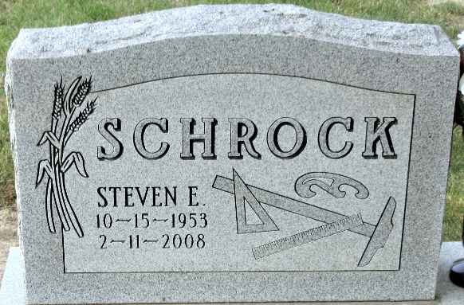
Photo by Alicia Kneuss

Steven E. Schrock, 54, of Carmel, Ind., formerly of Decatur, died Monday, Feb. 11, 2008, at Methodist Hospital, Indianapolis. Born Oct. 15, 1953, in Decatur, he was the son of Elizabeth (Olalde) and the late Andrew D. Schrock.
He was a member of Carmel United Methodist Church. He was Project Manager for Situs Realty Co., Indianapolis.
Surviving is his mother, Elizabeth "Liz" Colter of Decatur; daughter, Tarrah M. Schrock of Carmel; brother, Bradley E. Schrock of Decatur; and granddaughter, Kassidy R. Schrock of Carmel. He was also preceded in death by a brother, Korben.
Funeral service is 11 a.m. Friday at Haggard & Sefton Funeral Home, 225 W. Adams St., Decatur. The Rev. Mo Hodge officiating. Visitation is from 2 to 4 and 6 to 8 p.m. Thursday at the funeral home. Burial in Decatur Cemetery.
Memorials to his granddaughter's education fund or St. Vincent Hospital Foundation (Steven Schrock).

Journal Gazette, Allen County, Indiana
Wednesday, February 13, 2008

