Margaret Annette (Patterson) Schrock
July 9, 1850 – September 29, 1915

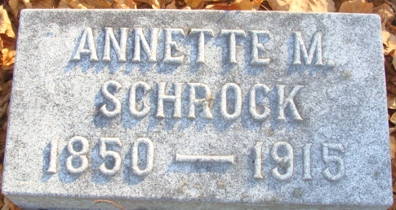
Photo by Alicia Kneuss

Margaret Annette Schrock
in the Indiana, U.S., Death Certificates, 1899-2017
Name Margaret Annette Schrock
[Margaret Annette Patterson]
Gender Female
Race White
Age 65
Marital Status Widowed
Birth Date 9 Jul 1850
Birth Place Adams Co. Indiana
Death Date 29 Sep 1915
Death Place Decatur, Indiana, USA
Death Registration Date 1910 - 1919
Father James Patterson
Mother Eliza Ann Peterson
Informant: Mrs. G. L. (Lila) Schrock Myers; Abingdon, Illinois
Burial: September 30, 1915; Decatur Cemetery

