Korben K. Schrock
August 23, 1952 – May 11, 2006

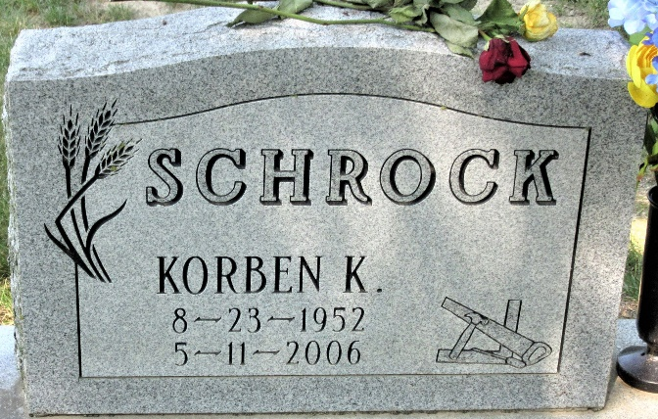
Photo by Alicia Kneuss

Korben K. Schrock, 53, Fremont, formerly of Decatur, died Thursday, May 11, 2006, 3:07 p.m., at Parkview Hospital, Fort Wayne. Born Aug. 23, 1952, in Fort Wayne, he was the son of Andrew D. Schrock and Elizabeth (Olalde). He married Kristin L. Gadsby on March 27, 2004.
He was a former contractor and member of the Moose Lodge, Angola.
Surviving are his mother, Elizabeth "Liz" Colter of Decatur; wife, Kristin L. Schrock of Fremont; one son, Korben K. Schrock Jr. of Decatur; one daughter, Allee E. Schrock of Fremont; two stepsons, Jesse L. Gadsby and Joshua M. Gadsby, both of Fremont; and two brothers, Steven E. Schrock of Carmel and Bradley E. Schrock of Decatur; two step brothers, Brett Colter of South Bend, and Terry Colter of Fort Wayne; and step sister, Cheryl Anderson of High Bridge N.J. He was preceded in death by his father, Andrew D. Schrock.
Funeral service is 11 a.m. Tuesday at Haggard & Sefton Funeral Home, Decatur. The Rev. Mo Hodge officiating. Visitation is from 2 to 8 p.m. today at the funeral home. Burial in Decatur Cemetery.
Memorials to the Children's Education Fund.

News-Sentinel, Allen County, Indiana
Saturday, May 13, 2006

