Elizabeth Mae Schrock
July 20, 1880 – November 12, 1953

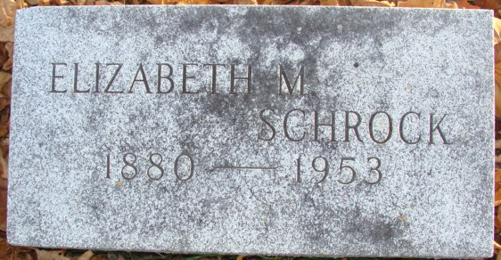
Photo by Alicia Kneuss

MISS ELIZABETH M. SCHROCK

UNION CITY – Having suffered a broken hip in a fall at her home last June, Miss Elizabeth M. Schrock died Thursday in Union City Hospital. Funeral services will be conducted at 2 p.m. Saturday in Zwick Funeral Home, Decatur, with burial in Maplewood Cemetery there.
Surviving is a sister, Mrs. G. G. Myers, Union City, and two brothers, W. P. Schrock, Decatur, and Dr. Herbert D. Schrock, Omaha, Neb.

The Muncie Evening Press; Muncie, Indiana
November 13, 1953
**
Elizabeth "Bessie" Mae Schrock in Family Tree
Father William Harrison Schrock
Mother Margaret Annette "Nettie" Patterson
Birth 20 Jul 1880 Decatur, Adams, Indiana, USA
Death 12 Nov 1953
Residence 1950 Union City, Randolph, Indiana, USA

